EXPERIMENT NO. 6

AIM: Build a web page enabling users to retrieve and display real time weather information for a specific city using AJAX. Student should explore free API providers offering weather data.

THEORY:

Introduction
A Weather Web Application is designed to retrieve and display real-time weather information for a specific city entered by the user. The application interacts with an external weather service API to fetch live data such as temperature, humidity, wind speed, and weather conditions. This improves user experience by providing instant and accurate weather updates without refreshing the webpage.
AJAX (Asynchronous JavaScript and XML)

AJAX is a technique used in web development to send and receive data from a server asynchronously without reloading the entire webpage. It allows dynamic updating of content, making web applications faster and more interactive.JavaScript Validation
JavaScript can capture form submission events and validate inputs before the form is submitted. If any field does not match the required pattern, an error message is displayed and the form submission is prevented.
Weather API
A Weather API is a service that provides real-time weather data for different locations. In this experiment, a free API such as WeatherAPI or OpenWeatherMap is used.
The API requires:
- API Key – A unique key for authentication
- Query Parameter (q) – City name or location
Example API Request:
http://api.weatherapi.com/v1/current.json?key=YOUR_API_KEY&q=Mumbai
The API responds with structured JSON data containing weather details.

CODE:
<!DOCTYPE html>
<html lang="en">
<head>
<meta charset="UTF-8">
<meta name="viewport" content="width=device-width, initial-scale=1.0">
<title>Weather App</title>
<style>
body {
font-family: Arial;
text-align: center;
margin-top: 50px;
}
input, button {
padding: 10px;
margin: 5px;
}
#weather {
margin-top: 20px;
font-size: 18px;
}
</style>
</head>
<body>
<h2>🌦 Weather App</h2>

<input type="text" id="city" placeholder="Enter city name">
<button onclick="getWeather()">Get Weather</button>

<div id="weather"></div>

<script src="script.js"></script>
</body>
</html>

Script.js

function getWeather() {
const city = document.getElementById("city").value;

const apiKey = "a9f9f2696fa34111ba7184211261404"; // replace this
const url = `http://api.weatherapi.com/v1/current.json?key=${apiKey}&q=${city}`;

fetch(url)
.then(response => response.json())
.then(data => {
if (data.cod === "404") {
document.getElementById("weather").innerHTML = "City not found!";
return;
}

// const temp = data.main.temp;
// const weather = data.weather[0].description;
// const humidity = data.main.humidity;
console.log(data);
document.getElementById("weather").innerHTML = `
<h3>${city}</h3>
<p> Temperature: ${data.current.temp_c}°C</p>
<p>Feels Like: ${data.current.feelslike_c}°C</p>
<p>Humidity: ${data.current.humidity}%</p>
<p> Wind: ${data.current.wind_kph} km/h (${data.current.wind_dir})</p>
<p>Visibility: ${data.current.vis_km} km</p>
<p>Cloud: ${data.current.cloud}%</p>
<p> UV Index: ${data.current.uv}</p>
`;
})
.catch(error => {
console.log(error);
document.getElementById("weather").innerHTML = "Error fetching data!";
});
}

OUTPUT:
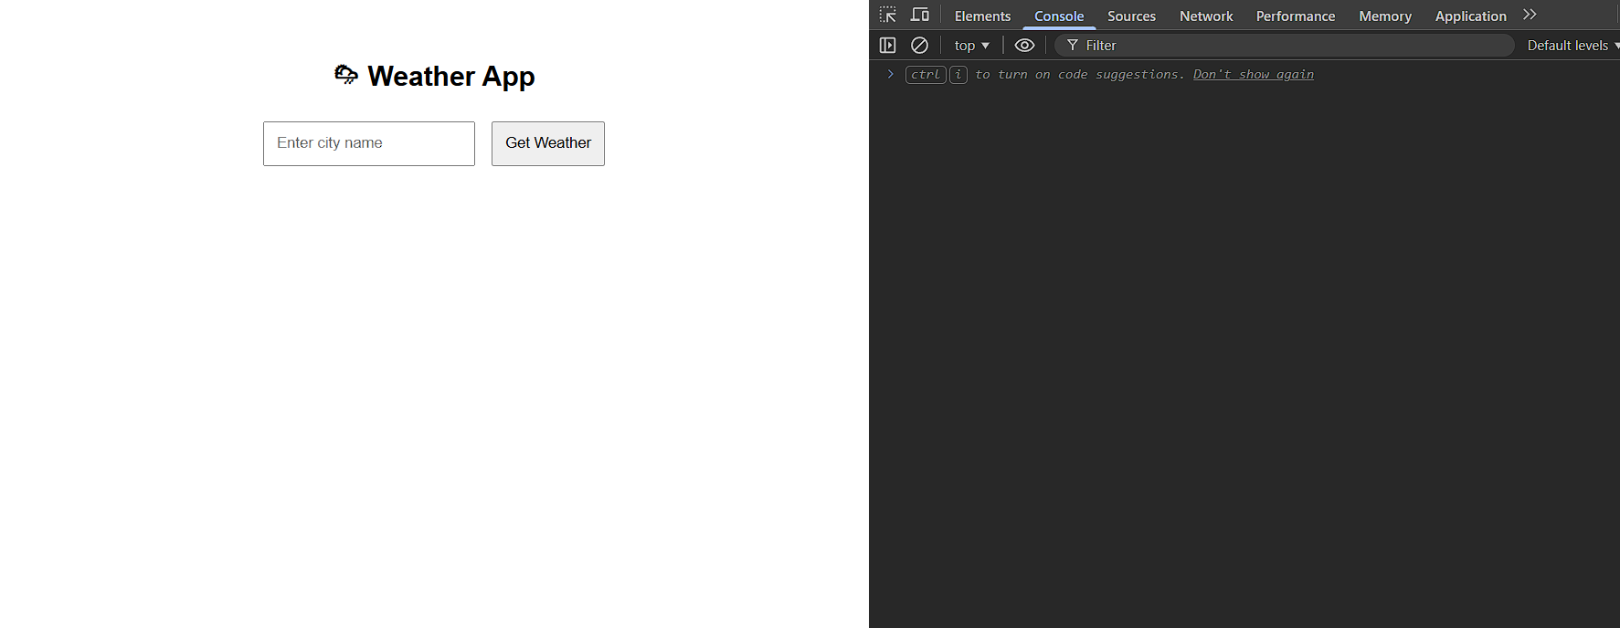
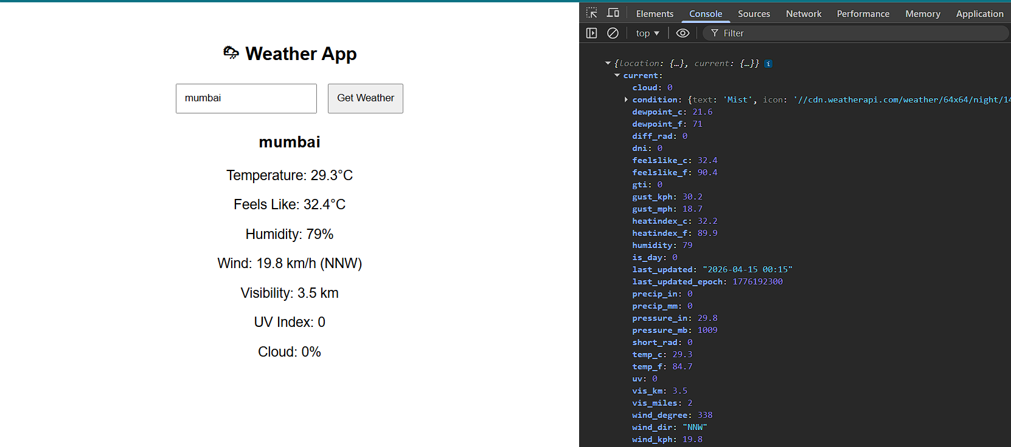

CONCLUSION: The Weather Web Application demonstrates how AJAX and APIs can be used together to build interactive web applications. By using JavaScript and external weather services, real-time data can be fetched and displayed efficiently. This experiment helps in understanding client-server communication, JSON handling, and dynamic UI updates.

